

SCS DTACC Messaging Group

Veritas CFS (Cluster File System)
Solaris 10

for TIBCO EMS

Certification Report

Version | 4.0
Date | August 21, 2006
Author | SCS DTACC Messaging Group
Status | Draft

Revision History

Version | Date | Author | Description
1.0 | June 12, 2006 | Andy Bither | Original draft version of document.
2.0 | June 29, 2006 | Andy Bither | Incorporate changes suggested by Messaging Team
3.0 | July 13, 2006 | Andy Bither | Incorporate new changes suggested by Messaging Team (consistency and appendix data)
4.0 | August 21, 2006 | Andy Bither | Final Version

Table of Contents
1 Executive Summary 6
1.1 Background 6
1.2 Objective 6
1.3 Scope 7
1.3.1 Functional 7
1.3.2 Performance 7
1.3.3 Resiliency 8
1.4 Findings 8
1.4.1 Issues 8
1.5 Next Steps 8
1.5.1 Solaris 10 8
1.5.2 Linux 9
1.5.3 Windows 9
2 Environment Setup 10
2.1 Veritas Cluster Setup 10
2.2 Active/Active EMS Failover Configuration 11
2.3 Host Environment Details 12
2.4 TIBCO EMS Configuration 13
2.5 Veritas CFS Configuration 15
3 Functional Testing 16
3.1 Functional Testing Summary 16
3.1.1 Software Failure Testing 16
3.1.2 Network Hardware Failure Testing 17
3.1.3 Machine Hardware Failure Testing 18
3.2 Connection Failover Testing 20
3.3 Message Loss Testing 23
3.4 Pending Message Recovery Testing 25
3.5 Hardware Failure Testing 26
3.5.1 Disable public network adaptor on the active EMS server machine 26
3.5.2 Disable private CFS heartbeat adaptors on the primary CFS machine 26
3.5.3 Reboot Primary Node 27
3.5.4 Power Down Primary Node 29
3.5.5 Client Reconnect Time Test 30
4 Performance Testing 31
4.1 VCS versus CFS 31
4.2 EMS running on CFS Primary Node versus Secondary Node 31
5 Resiliency Testing 33
6 Issues 34
6.1 Summary 34
6.2 Veritas CFS 34
6.3 Tibco EMS 35
6.3.1 EMS Server 35
6.3.2 Java Client Reconnect Problem with Multiple Failovers 35
6.3.3 Client Reconnect - TCP Socket Timeout 38
6.3.4 Consumer Receives Duplicate Messages 38
7 Appendix A – Connection Test Results 40
8 Appendix B – Hardware Reboot Failure Test Logs 41
9 Appendix C – Hardware Power Down Failure Test Logs 42
10 Appendix D - Pending Message Recovery Test Results 45
11 Appendix E – Performance Test Results 49

Executive Summary

Background
Messaging systems are the backbone of the business applications at Credit Suisse. It is essential that these systems be as resilient as possible, staying operational continuously without losing any messages.
TIBCO EMS (Enterprise Messaging Service) is the firm’s strategic platform for high-speed asynchronous messaging because of its performance, flexibility, and reliability. Fault tolerance is one of its features. In this mode, two servers run as a fault tolerant pair. One runs as the primary active server and the other runs as a backup in “hot standby” mode. When the primary fails for any reason, the backup server becomes the active server and all of the EMS clients reconnect automatically and seamlessly to it.
EMS fault tolerance is enabled through the use of shared state technology. There are many providers of shared state technology, such as Sun NFS, Veritas VCS, and Veritas CFS. EMS will work with any shared state technology that supports the following four requirements as stated by TIBCO:
- Write Order. The storage solution must write data blocks to shared storage in the same order as they occur in the data buffer. (Solutions that write data blocks in any other order (for example, to enhance disk efficiency) do not satisfy this requirement.)
- Synchronous Write Persistence. Upon return from a synchronous write call, the storage solution guarantees that all the data has been written to durable, persistent storage.
- Distributed File Locking. The EMS servers must be able to request and obtain an exclusive lock on the shared storage. The storage solution must not assign the locks to two servers simultaneously. EMS servers use this lock to determine the primary server.
- Unique Write Ownership. The EMS server process that has the file lock must be the only server process that can write to the file. Once the system transfers the lock to another server, pending writes queued by the previous owner must fail.
Currently the Athena application in FID uses EMS in a fault tolerant mode using NFS as the shared state. NFS has proved to be unreliable during failover and is not recommended by Tibco. The Veritas VCS system is a better solution than NFS but could take up to 20 minutes to failover and requires a special script procedure, which adds to the risk factor.
Veritas CFS was considered as the shared state solution because it provides a superior solution for EMS failover. With CFS, the failover is nearly instantaneous and is completely automatic, seamless, and transparent to the application without requiring any script procedures. Additionally, it meets all of Tibco’s shared state requirements for running EMS in a fault tolerant configuration.

Objective
The objective is to evaluate whether CFS facilitates the instantaneous failover of EMS in the fault tolerant configuration. In addition tests were conducted to determine the functionality, performance, and resiliency of EMS 4.3.0 in the CFS environment.
The specific expectations of the evaluation are:
- During software or hardware failures, the EMS servers should failover and all clients should reconnect automatically and seamlessly without any loss of data.
- The failover should be close to instantaneous.
- CFS should have minimal impact on EMS persistent messaging performance.

Scope
The scope of the evaluation was limited to EMS 4.3.0 running on two Solaris 10 (64 bit) hosts configured in a Veritas CFS cluster. For the purposes of this evaluation the test plan encompassed the following three silos; functional, performance, and resiliency.

Functional
The following test categories were run in order to validate the functional aspects of EMS server failover. The objectives and description of each test category are listed.
- Connection Failover Testing: To determine the length of time EMS takes to recover connections during failover. See Connection Failover Testing for details.
- Message Loss Testing: To verify that EMS does not lose any persistent failsafe messages during failover. See Message Loss Testing for details.
- Pending Message Recovery Testing: To determine the length of time EMS takes to recover pending messages during failover. See Pending Message Recovery Testing for details.
- Hardware Failure Testing: To validate CFS and EMS failover under specific hardware failure conditions. See Hardware Failure Tests for details.

Performance
The following tests were run in order to validate the performance aspects of EMS server failover.
- Compare EMS performance differential between CFS and VCS [note: NFS out of scope for this evaluation]. CFS adds a minimal 3% performance penalty.
- Compare EMS performance when the active server runs local to the CFS primary lock manager as compared to when it runs remotely. No difference was observed. This means there will be no EMS performance loss after a failover to the backup server. It also means there is no requirement to ensure the active EMS server runs on the CFS primary lock manager node.

Resiliency
A long running test was run over a period of 2 weeks to verify the stability of EMS in the CFS environment. In this test, EMS clients were running continuously while EMS failed over back and forth once every hour.

Findings
DTACC recommends CFS as the strategic platform for EMS messaging in the Solaris 10 environment.
All tests produced the expected results and EMS performance was not adversely affected by CFS. We found a couple of minor issues that are described in detail in the Issues section of this document. These issues are certainly not “show stoppers” and have more to do with configuration and application design.

Issues
- A reconnection bug was found in the Java API that is being addressed by Tibco.
- TCP timeout issue prevents an EMS client from reconnecting in a timely manner during a failover caused by hardware failures. This problem is specific to TCP and not a result of any problems in CFS or EMS. To circumvent this issue, Tibco plans to implement a high-level heartbeat protocol between the client and the server. This enhancement will be in EMS version 4.4 due to be released in Q3 2006. We plan to test this feature when we receive the new release.
- Duplicate Messages cannot be prevented during failover. Due to race conditions that exist during a failover, it is not possible for EMS to guarantee that a message will not be re-delivered. Therefore, any application planning to use EMS in a fault tolerant configuration must be able to handle duplicate messages.

Next Steps

Solaris 10

Java Reconnection Bug Issue
This issue is under investigation as a Tibco SR. DTACC will follow through with this issue until it is resolved.

Version 4.4 Client Connection Enhancement
DTACC will follow through with this issue and retest the hardware failure tests when the new version is released.

Linux
We are targeting the Egenera Blade frame hardware running Linux SLES9 (64 bit) as the strategic Linux platform. Egenera does not support SCSI 3 reservation, which is required by CFS. Egenera plans to support SCSI 3 reservation by Q1 2007. At that point, DTACC plans to certify CFS on Egenera..
The Pathfinder Direct application currently uses the IBM Blade architecture and they have expressed interest in running EMS in a CFS environment on that platform. Currently there are some SAN configuration and connectivity issues with the IBM Blade architecture that prevent the Disk Storage team from supporting CFS on that platform. If those issues are resolved, then certifying CFS for IBM Blades could be a possibility.
EMS does not currently run on white boxes such as HP Reliance 580/585. Currently there is no plan to certify EMS on white boxes due to lack of demand.

Windows
There are some applications in London that use EMS in a tier 2 windows environment. These applications are possible candidates for the CFS technology. Currently Veritas does not support CFS on windows; however, Polyserve GFS has been suggested as a viable solution. There is no windows certification ETA at this point.

Environment Setup

Veritas Cluster Setup
The diagram below shows the basic relationship between CFS, the EMS servers, and the EMS Clients. Machines pns51a-0003a and pns51a-0003b host the CFS software and are both connected to a shared high-speed SAN disk.
Each machine contains identical CFS software components that communicate with each other via heartbeats. One of the CFS instances is the primary lock manager for the shared state disk and the other CFS instance is the secondary lock manager.
Each machine also contains identical EMS servers that communicate with each other via heartbeats and share the same state through the shared disk controlled by CFS. The first EMS server to begin is the primary “active” server. When the other one begins it is the secondary “standby” server.
EMS Client applications run on a third machine, nys45a-6902, and connect to either one of the EMS servers on the CFS cluster. The client’s EMS connection string specifies both urls, and the connection is automatically made to the “active” EMS server.

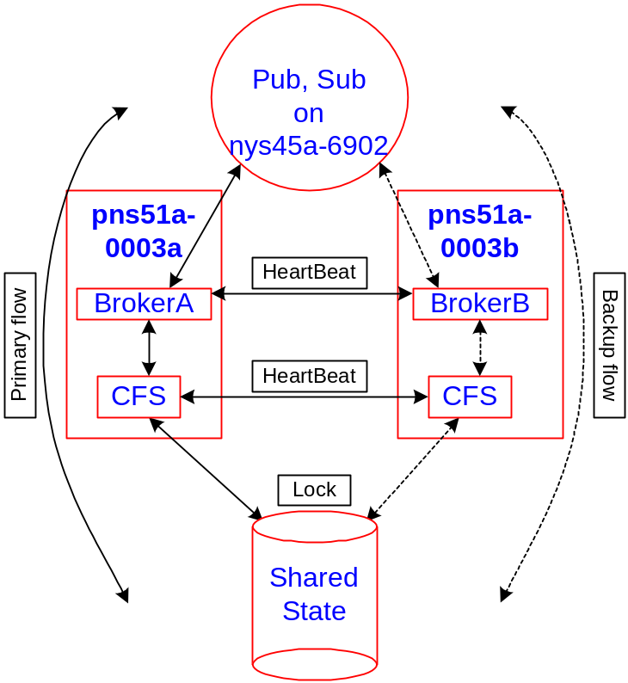
Figure 1 – CFS Cluster Setup

Active/Active EMS Failover Configuration
This configuration is used to prove that both hosts can be fully utilized in a CFS cluster by having an active EMS server running on each host simultaneously. Two EMS server pairs are configured.
- Bench is active on Node A while its fault tolerant standby runs on Node B.
- Bench2 is active on Node B while its fault tolerant standby runs on Node A.
EMS Failover Configuration:
- /app/ems_store1 is the CFS shared state file system for the bench EMS server. In this test, host pns51a-0003a is the primary lock manager node for this CFS file system. Additionally, the active EMS server runs on this host and the fault tolerant standby EMS server runs on the other host.
- /app/ems_store2 is the CFS shared state file system for the bench2 EMS server. In this test, host pns51a-0003b is the primary lock manager node for this CFS file system. Additionally, the active EMS server runs on this host and the fault tolerant standby EMS server runs on the other host.
- The two EMS server pairs are running in active-active mode. EMS clients connect to each EMS server pair from a third host, nys45a-6902.
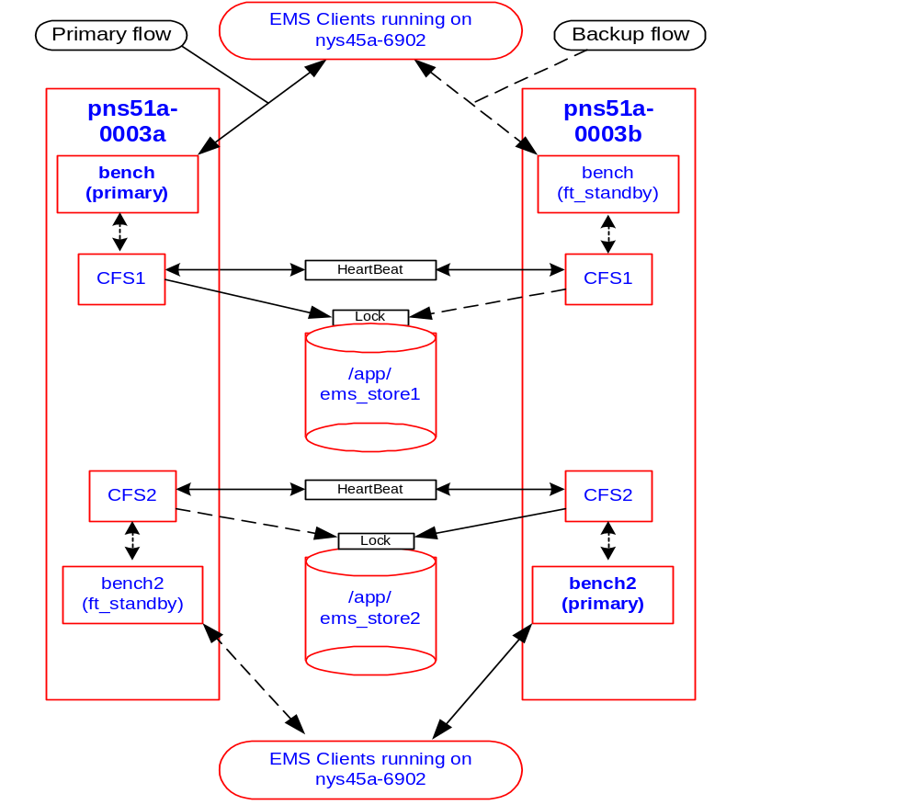Figure 2 – Hardware Failure Test Configuration

Host Environment Details

Host Information
Host Name | pns51a-0003a | pns51a-0003b
Application Designation | EMS Server | EMS Server
Operating System | Solaris 10, CSG 2.0 | Solaris 10, CSG 2.0
Main Memory (RAM) | 16 GB | 16 GB
No of CPU | 4 | 4
Vendor ID | Authentic AMD | Authentic AMD
CPU family | SUNW | SUNW
Model | UltraSPARC-IIIi | UltraSPARC-IIIi
Model Name | Sun Fire V440  AMD Opteron™ Processor | Sun Fire V440  AMD Opteron™ Processor
Stepping | 1 | 1
CPU MHz | 1281 | 1281
CACHE Size | 1024 KB | 1024 KB
FPU | Yes | Yes
FPU_EXECUTION | Yes | Yes
CPUID level | 1 | 1
WP | Yes | Yes
Network Connectivity | GigE Copper | GigE Copper

Host Bus Adapter (HBA) and Fiber Channel Switch (FCS) Information
HBA Model | 2 Emulex LP 9K (9002) PCI
I/O Bus Speed | 66 MHz
FCS | Cisco MDS 9506, hosts and 3-PAR connected at 2 gbps

Disk Drives – two LUNS controlled by separate CFS instances
Vendor | 3-PAR
Model | S400
Configuration | “Interrupt Coalescing Disabled”
Disk Block Size | 8K
Raw disk performance | 1800 wps

LUN Information – Note each LUN controlled by a separate CFS instance
LUN 1 | 18 GB mounted as /app/ems_store1
LUN 2 | 18 GB mounted as /app/ems_store2

Table 1: Environment Details

Best Practice
Disable “Interrupt Coalescing. When “Interrupt Coalescing” is disabled, there is no I/O buffering on the 3-PAR side. Every write is done immediately for better performance. The current default setting is “Interrupt Coalescing Enabled”. In this mode, we achieved only 900+ wps. After disabling this setting, we achieved 1800+ wps. Consequently, 3-PAR intends to make “Interrupt Coalescing Disabled” the default setting as requested by Credit Suisse.

TIBCO EMS Configuration
The information in Table 2 describes the TIBCO EMS version.

EMS Miscellaneous Information
Version | 4.3.0

Table 2: EMS Miscellaneous Information

The important configuration parameters for a broker instance are specified in the ‘tibemsd.conf’ main configuration file. Table 3 shows the main configuration of each broker in the failover tests. Note both primary and secondary EMS servers are configured the same way.

EMS Configuration Information (tibemsd.conf)
store | /app/ems_store1
store_minimum | 1GB
store_crc | Disabled
store_truncate | Enabled
max_connections | 0
max_msg_memory | 0 MB
msg_swapping | Disabled
authorization | Enabled
flow_control | Enabled
log_trace | DEFAULT,+CONNECT,+PRODCONS,+FLOW,+AUTH
server_rate_interval | 1
statistics | Enabled
rate_interval | 3
detailed_statistics | PRODUCERS,CONSUMERS
statistics_cleanup_interval | 0
max_stat_memory | 64 MB
track_message_ids | Enabled
track_correlation_ids | Disabled
reserve_memory | 16 MB
user_auth | Local
ft_heartbeat | 1 second
ft_activation | 3 seconds
ft_reconnect_timeout | 1200 (20 minutes)

Table 3: EMS Configuration Information

Best Practice
To cause EMS failover within 3 seconds of hardware failure
- ft_hearbeat = 1 second (send heartbeat every second)
- ft_activation = 3 seconds (fail over if heartbeat not received within 3 seconds)

To prevent EMS from disconnecting a client prematurely during a failover. See Client TCP timeout issues in section 6.
- ft_reconnect_timeout = 1200 seconds (20 minutes).

Each specific topic and queue is created dynamically by the client application. Each destination inherits its properties from a base that specifies the “failsafe” property. This guarantees that persistents messages are written to disk synchronously before the send() call completes.

Topic and Queue Configuration Information
<Topic Base Name> secure, failsafe, flowControl=128KB
<Queue Base Name> secure, failsafe

Table 4: Topic and Queue Configuration Information

Connection Factory Configuration Information (Client Parameters)
name | ConnectionFactory
type | generic
url | tcp://pns51a-0003a.fir.fbc.com:8888,tcp://pns51a-0003b.fir.fbc.com:8889
connect_attempt_count | 30
connect_attempt_delay | 1000
reconnect_attempt_count | 1200
reconnect_attempt_delay | 1000

Table 5: EMS Connection Factory Configuration Information

QOS used for all client message exchange
Persistent Mode | TIBEMS_PERSISTENT
Transacted Mode | TIBEMS_SESSION_NOT_TRANSACTED
Acknowledge Mode | TIBEMS_AUTO_ACKNOWLEDGE

Veritas CFS Configuration

The information in Table 6 describes the Veritas CFS configuration. Note all configuration parameters use the default values recommended by Veritas.

Veritas CFS Configuration
Version | 4.1
I/O Fencing | Not used
cvm_timeout | 200 seconds
gab_timeout | 15 seconds

Table 6: Veritas CFS Miscellaneous Information

Best Practice
Disable I/O fencing in order to achieve best performance. I/O fencing is part of the kernel modules and adds a small performance overhead because additional messages are sent over the heartbeat channels. I/O fencing makes use of the hardware SCSI-3 reservation feature of the disk in order to synchronize the write operations between the CFS nodes.

The main benefit of I/O fencing is to prevent data storage corruption when multiple nodes perform concurrent disk write operations. This feature does not benefit EMS because only the “active” EMS server in a fault tolerant pair can write to disk. EMS guarantees this through the use of CFS mandatory locking.

One final benefit of I/O fencing is to prevent the “split brain” condition during failover. This is an extremely rare condition that could only happen if both CFS nodes are operational but neither is receiving heartbeats. Both of the private heartbeat networks and the public network would have to go down for this condition to occur. In that condition each CFS node would become the primary CFS lock manager. In this unlikely condition, I/O fencing would prevent data corruption if both CFS nodes wrote concurrently to the disk.

If the application wants the 100% guarantee that I/O fencing provides and is willing to give up some performance, then the disk storage team must configure the SCSI-3 reservation feature on the LUN. Note SCSI-3 is currently disabled from the LUNs used for this certification testing.

Functional Testing

Functional Testing Summary
A number of different kinds of software and hardware failure tests were conducted in order to verify correct EMS failover and seamless client reconnection under all possible types of failures. Two very different types of tests were conducted.
EMS Software Failure Tests: CFS was not a factor in these tests and there was no CFS failover. The purpose of these tests was to create an EMS failure, and to observe the behavior of EMS failover in the CFS environment.
Hardware Failure Tests: Designed to test the behavior of both CFS and EMS during specific types of hardware failures. There were two categories of hardware failure tests.
- Network hardware failure tests were performed to observe the behavior of both CFS and EMS during a network failure.
- Machine hardware failure tests were designed to cause a failover of both CFS and EMS. The purpose was to observe the behavior of both CFS and EMS failing over at the same time.

Software Failure Testing
Three categories of software failure tests were conducted. These software tests consisted of terminating the primary EMS server and observing EMS fail over to the secondary. By design, CFS was unaffected by these tests so EMS was the only variable.
Client applications were connected to the primary EMS server during these tests and their behavior was also observed during the EMS failover. The client behavior was tested using all three language bindings (Java, C/C++, and C#) running on three different platforms (Solaris, Linux, and Windows).
In all of the software failure tests, EMS failed over in sub-second time. The secondary server immediately detected connection loss to the primary server, acquired the CFS lock, and became the active server. CFS facilitated the sub-second failover by making the file system readily available to the secondary EMS server.

Connection Failover Testing
The objective was to determine how quickly EMS could recover pending client connections from the Meta Data during an EMS failover.
Clients were connected to the EMS server, having various numbers of topic and queue connections but not exchanging any messages. While the clients were connected, the primary EMS server was shutdown in three different ways (graceful, kill, and kill -9). The length of time for the secondary EMS server to become active and recover all of the client connections was observed.
In all cases, EMS failed over in sub-second time regardless of how the primary EMS server failed. The length of time to recover the client connections was a linear function of how many connections there were. There was no time difference between recovering either queue or topic based connections.

Message Loss Testing
The objective was to verify that no persistent failsafe messages would be lost during an EMS failover. Secondly, to determine the time required for clients to reconnect to the new EMS server during an EMS failover.
Several C++, Java, and C# clients were exchanging messages while EMS was failed over back and forth. The consumer logic detected out of sequence and duplicate message conditions. Both producers and consumers detected and reported EMS failover.
No messages were lost or duplicated during EMS failover and all clients reconnected within a few seconds.
CAUTION
A Sun Solaris 8 bug has been discovered that is isolated to Java clients that specify large heap parameters on the JVM. The manifestation is that after several failovers, the client will hang. See details under section 6.3.2 Java Client Reconnect Problem with Multiple Failovers.

Pending Message Recovery Testing
The objective was to determine the time required for the new EMS server to recover pending messages during an EMS failover.
A series of tests were run that created pending messages in the EMS server. Then the primary EMS server was shutdown and the length of time for the secondary EMS server to recover the pending messages was observed.
CFS facilitated the instantaneous failover of EMS after which EMS recovered the pending messages.
EMS recovered 125,000 pending messages in about 1 second. The length of time to recover pending messages was a linear function of the number of pending messages to recover. The maximum test case created 6,000,000 pending messages, which took over 80 seconds to recover. Note the pending message recovery time is a function of EMS recovery and has nothing to do with CFS.

Network Hardware Failure Testing
Two categories of hardware failures were conducted 1) network adaptor card failures and 2) machine failures. In all of these tests the active EMS server was local to the CFS primary lock manager node.
For the network failure tests, two tests were conducted. One simulated a failure of the private CFS heartbeat adaptors and the other test simulated a failure of the public network adaptor.

Private CFS Heartbeat Adaptor Failure
This test consisted of disabling the private CFS heartbeat adaptors on the primary CFS machine. It produced the expected result. CFS heartbeats continued to be sent successfully over the low priority network (public network) and no CFS failure occurred.

Public Network Adaptor Failure
This test consisted of disabling the public network adaptor on the primary CFS machine. It produced the expected result. There was no CFS failover because CFS heartbeats were still being exchanged via the CFS private network adaptors.
The EMS secondary server detected loss of heartbeats, and attempted to become the active server. However, it could not get the CFS lock because the primary EMS server was still active and still retained the lock.

CAUTION
If the public network adaptor fails on the active EMS server machine, then EMS will not fail over to the secondary server. Clients will lose connection to the EMS primary server and try to reconnect but will not be able to. This will result in a “hung” condition for the application.

If the EMS primary server is subsequently brought down, then the EMS secondary server will become the active server and clients will reconnect to it. At that point the application will resume normal operation.

NOTE: Adequate network monitoring must be in place in order to detect network outages.

Machine Hardware Failure Testing
Two machine failure conditions were tested in order to observe CFS and EMS failover. Both hardware failure tests were ungraceful creating an OS Panic. As a result the OS was not able to close any of the TCP socket connections nor flush any of the OS buffers.
In both tests, both CFS and EMS failed over as a result of losing heartbeats. For EMS, failure is detected when heartbeats are missed in a 3 second period. For CFS, failure is detected when heartbeats are missed in a 15 second period. The common observations in these tests were:
- EMS started to failover within 3 seconds of the hardware failure. It then tried to get the lock and blocked until CFS failed over.
- CFS failed over 17 seconds later. EMS then got the lock and within 1 second recovered the meta-data and became the active server.
- EMS clients on the other hand took several minutes to reconnect to the new EMS server. Heartbeats are not sent from the EMS server to the client. Thus the client depends on the TCP socket layer to provide a timeout exception in order to initiate the reconnection logic.
From the test results run thus far, no definitive conclusions can be made regarding EMS client TCP timeouts. One additional test is scheduled in order to discover how long it takes Java and C++ clients to reconnect in both Solaris 8 and Solaris 10 environments.

Reboot Primary CFS Machine
This test consisted of reboot with the –nd option to cause OS Panic.
CFS and EMS failed over as described above. The clients reconnected to the secondary EMS server after 3 minutes. This coincides with the time that the primary node came back up after the reboot. In this test, the primary CFS machine came back up before the EMS client TCP sockets timed out. The OS closed the sockets when it came up causing the clients to reconnect.

Power Down Primary CFS Machine
This test consisted of powering down the primary CFS machine to cause OS Panic followed by restarting the machine after 10 minutes.
CFS and EMS failed over as described above. However, the client reconnection sequence was different than in the reboot test.
- The Java producer client reconnected 9.5 minutes after the primary CFS machine was powered down but before it was powered back up. It therefore seems like the TCP timeout for socket send operation is less than that for socket receive.
- Node A was powered back up 10 minutes after being powered down.
- The Java consumer client reconnected 1 minute after Node A was powered back up. It seems like Node A closed the socket connection when it came back up, causing the client to perform reconnect logic.
- From these observations, the TCP timeout for a socket send operation is less than the timeout for a socket receive operation. Furthermore, the socket receive timeout is greater than 10 minutes. The timeout value is not know at this point because it appears the socket was closed by Node A when it was powered back up.
- One additional test described below is scheduled in order to determine the client reconnect times when the hardware remains down indefinitely.

Client Reconnect Time Test (to be scheduled)
This test is a repeat of the Power Down test except that the machine will be left down until all of the clients reconnect to the secondary EMS server. The purpose of this test is to observe the producer and consumer client reconnect times for C++ and Java versions running in Solaris 8 and Solaris 10 platforms.
From the observations made in previous tests, and from communication with Tibco, the client reconnection time depends on the underlying TCP socket timeout. This timeout value depends on the OS platform and whether a send or receive operation is being performed.
Furthermore, the client reconnect time is also affected by the language binding. Java depends on the JVM implementation, which is different for each OS platform.

Connection Failover Testing
Objective: To determine the length of time EMS takes to recover connections during failover.
Description: A series of tests were run varying the number of client connections using queues and topics.
In each combination, the EMS server was failed over in three ways.
- Admin console “shutdown” command - graceful shutdown.
- “kill” EMS Broker pid.
- “kill –9” EMS Broker pid.

Each type of failover will be performed during the following types of client application scenarios.
- Five variations of clients using only queue destinations.
- Five variations of clients using only topic destinations.
- Three variations of clients using mixed queue and topic destinations.

Results:
- In all cases the standby EMS server immediately detected missing connection from the primary server, acquired the meta-data lock, and assumed role of active server.
- In all cases EMS failed over correctly in sub-second time.
The time required for all of the clients to reconnect is a linear function of the number of connections. There wasn't a noticeable difference between reconnecting to either queue or topic connections. Note there was no message exchange between clients during this test.
The following graphs show the time for the EMS server to recover all of the client connections.

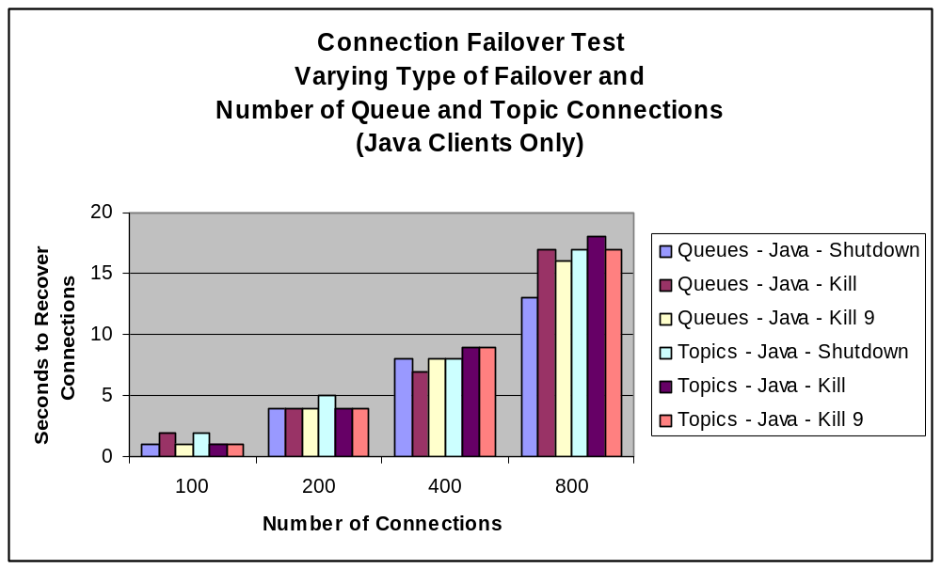
Figure 3 – Connection Failover Tests – Java Clients use Queues or Topics (not mixed)

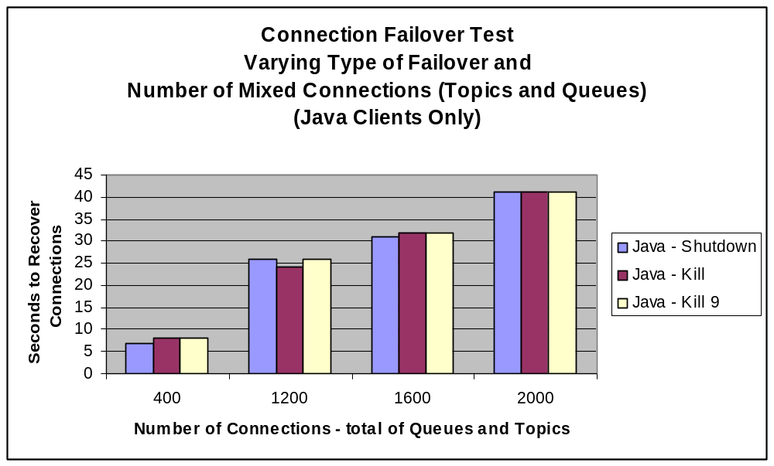
Figure 4 – Connection Failover Tests – Java Clients use Mixed Topics and Queues

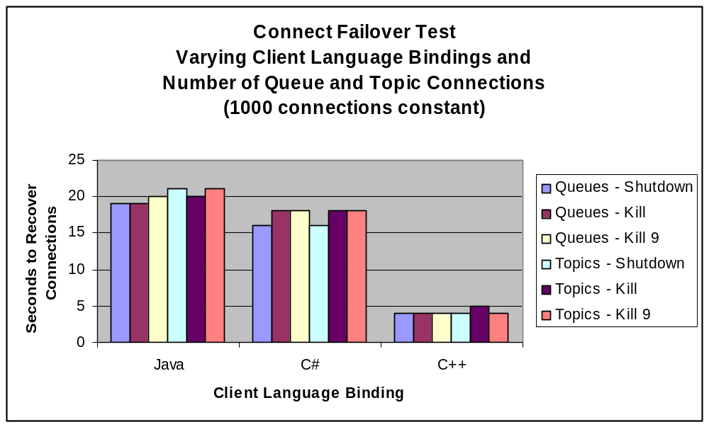
Figure 5 – Connection Failover Tests – Java, C++, and C# Bindings

Message Loss Testing
Objective: To verify that EMS does not lose any persistent failsafe messages during failover.
Description: Several message loss detection clients were running while EMS was failed over back and forth.
C++, Java, and C# clients were running from Solaris 8, Linux, and Windows. A total of 600 producers were publishing at a rate of 10 messages per second to 300 queues and 300 topics. These messages were received by 600 consumers. At any point in the failover, we noticed EMS had about 300 pending messages.
When a failover occurs, the API is notified at the socket level and attempts to reconnect each connection. All of this happens without the awareness of the client application. When the reconnection is successful, the API calls the Connection Exception Handler if one is registered. That is the application’s only way to know that a failover has happened.
The test client application logic checks sequence numbers on a connection basis. The producers write the sequence number in each message and the consumers check the sequence against what is expected. The consumers report an error for sequence gaps and a warning for duplicates. Note in a failover, EMS cannot guarantee that a duplicate message will not be duplicated.
The client application logic also detects the failover and sets a “failover flag” for the receive logic. After receiving a message, if the flag is on, it means this is the first message after the failover. It resets the flag and computes the length of time from the last message received. This indicates the amount of time the client was not receiving messages during the failure.
Results:
  - No messages were lost or duplicated in this test.
  - All client connections reconnected within a few seconds.
  - No appreciable reconnect time for C++ and Java clients, which were running in NY domain UNIX hosts. The C# clients took longer to reconnect because they were running on a Windows PC located in London, which resulted in more TCP hops to the EMS server.
The reason there is a minimum and maximum reconnect time is because each client connection reconnects serially instead of all at once.
Java Client Bug Discovered:
For java clients only, a bug was found where after four successful failovers, the client failed to reconnect on a subsequent failover.

CAUTION
A Sun Solaris 8 bug has been discovered that is isolated to Java clients that specify large heap parameters on the JVM. The manifestation is that after several failovers, the client will hang. See details under section 6.3.2 Java Client Reconnect Problem with Multiple Failovers.
Results:
Message Loss Test – Three Failover Sequences
 | run1 |  | run2 |  | run3
 | Min | max | min | Max | min | max
C++ Queue | 4 | 10 | 9 | 13 | 10 | 10
C++ Topic | 4 | 10 | 9 | 13 | 1 | 16
Java Queue | 4 | 9 | 11 | 18 | 10 | 16
Java Topic | 4 | 9 | 11 | 18 | 10 | 16
C# Queue | 10 | 37 | 12 | 46 | 16 | 46
C# Topic | 10 | 37 | 11 | 46 | 13 | 46

Table 7 – Message Loss Test

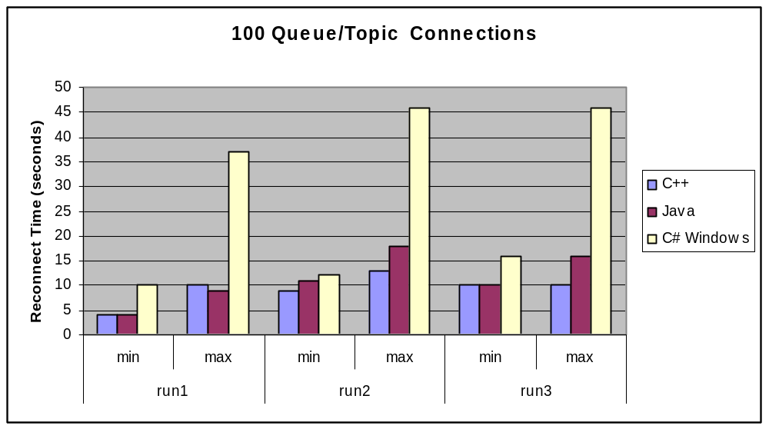
Figure 6 – Message Loss Test

Best Practice
For highest quality of service (no loss of messages and minimal duplicates during failover)
- Producer sends persistent messages
- Configure EMS destination as “fail-safe” to cause messages to be written before control returned to send() command.
- Set “track_message_ids” in EMS configuration to minimize duplicate messages from being sent by producer during EMS failover.
- Consumer session set “auto-ack” mode.

Pending Message Recovery Testing
Objective: To determine the length of time EMS takes to recover pending messages during failover.
Description: A series of tests were run, varying the number of publishers, subscribers, and published messages. These tests created pending messages in the EMS server. Measurements were noted from two different test sequences.
- EMS failure after pending messages had accumulated. The length of time for the secondary server to recover the pending messages was noted.
- Consumers were started after EMS recovered the pending messages. The length of time to receive 50% of the pending messages was noted.
Results: The two graphs below show that both EMS recovery time and consumer receive time are a linear function of the number of pending messages in the EMS server.
The time to recover a normal amount of pending messages is quite negligible, about 1 second to recover up to 125,000 pending messages. The length of time to recover pending messages was a linear function of the number of pending messages to recover. The maximum test case created 6,000,000 pending messages, which took over 80 seconds to recover.
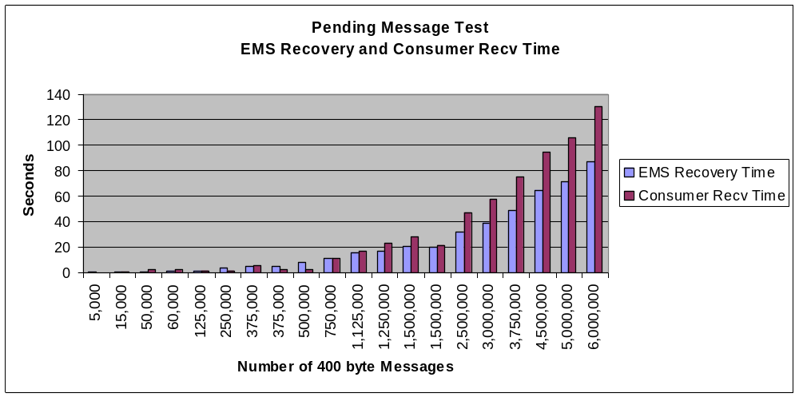
Figure 7 – Pending Message Test

Hardware Failure Testing

Disable public network adaptor on the active EMS server machine
Objective: To verify EMS heartbeat failover during a network hardware failure.
Description: Simulated public network adaptor card failure.
Results: The following observations were made.
- CFS did not failover because CFS heartbeats were still being exchanged via the CFS private network adaptors.
- The primary EMS server did not fail and continued to hold the CFS lock.
- The EMS secondary server detected loss of heartbeats, attempted to become the active server but failed to acquire the CFS lock because it was still being held by the primary EMS server. The EMS secondary server then reverted back to “standby” mode.
- Subsequently, the test restored the public network adaptor. EMS heartbeats were exchanged again and the EMS primary server remained active.
CAUTION
If the public network adaptor fails on the active EMS server machine, then EMS will not fail over to the secondary server. Clients will lose connection to the EMS primary server and try to reconnect but will not be able to. This will result in a “hung” condition for the application.

If the EMS primary server is subsequently brought down, then the EMS secondary server will become the active server and clients will reconnect to it. At that point the application will resume normal operation.

NOTE: Adequate network monitoring must be in place in order to detect network outages.

Disable private CFS heartbeat adaptors on the primary CFS machine
Objective: To verify CFS heartbeat failover during proprietary heartbeat network hardware failure.
Description: Simulated proprietary network adaptor card failure.
Results: CFS heartbeats continued to be sent successfully over the low priority network (public network) and no CFS outage occurred.

Reboot Primary Node
Objective: To verify EMS failover and client reconnection during a reboot that causes OS Panic. The time necessary to perform these functions was also measured.
Description: In this test, two active EMS server pairs were running, each one of them using a separate data store controlled by a separate CFS instance. The two EMS server pairs were setup as an active-active pair.
- The bench EMS server pair was active on Node A (pns51a-0003a). It used the /app/ems_store1 CFS file system, whose primary lock manager was running on Node A.
- The bench2 EMS server pair was active on Node B (pns51a-0003b). It used the /app/ems_store2 CFS file system, whose primary lock manager was running on Node B.
- EMS clients were connected to both bench and bench2 EMS servers, exchanging messages with each other.
Action: Node A was bounced using reboot -nd option to cause OS Panic.
Results:
- The EMS server on Node B stopped receiving heartbeats from the server on Node A and became the active EMS server within the 3 second heartbeat timeout. Node B EMS server then displayed messages in the log indicating intent to become the active server. It then proceeded to read the meta-data but blocked for 17 seconds.
The CFS log shows CFS did not fail over to Node B until 16 seconds after EMS failed over. This is because CFS has a longer heartbeat interval than EMS. Once CFS failed over, EMS was able to acquire the meta-data lock. At that point it took EMS 1 second to recover all of the pending connections (see details below).
- The CFS heartbeat configuration parameters cause the CFS failover to happen when the secondary lock manager misses 3 heartbeats in a 15 second period of time. It is because of this setting, that the shared state was not available to EMS immediately.
- During the failover, the active EMS server on Node B continued without interruption as Node B was already the primary lock manager node for that server and there was no failure on Node B.
- During the failover, the EMS clients were not immediately aware that the connection to the server was gone. As soon as Node A came back up the clients became aware that the connection was gone and performed reconnect logic. At that point they all reconnected seamlessly and automatically to the new EMS server and continued processing without any loss of messages.
TCP Timeout Notes:
- Because the reboot caused OS panic, the socket connections on Node A were not closed. Neither Node B nor the host that the clients were running on had any TCP indication that the connection to Node A was gone.
- As a result, the standby EMS server did not detect that the primary was gone until the heartbeat interval had elapsed. In this test we set heartbeats every second with a timeout after 3 seconds. After three seconds, EMS failed over and the standby server acquired the CFS lock on the data store.
- Note that CFS did not failover immediately because its heartbeat configuration parameters were set higher. It fails over only after it misses 3 heartbeats in a 15 second period of time. In our test, the EMS failed over in 3 seconds, then CFS failed over 17 seconds later. At that point, the EMS server was able to read the shared state and recovered all of the pending connections from the meta-data 1 second later.
- Similarly the client connections didn’t detect the connections were gone either. However, there is no heartbeat timeout interval for clients and the default TCP timeout is very high. We verified that when Node A came back up, the clients reconnected to Node B. This is because when Node A came back up, it closed the old sockets, which caused the client API to perform reconnect logic.
- Because of the TCP timeout behavior, we asked Tibco to make an enhancement with their client_heartbeat configuration logic. Currently, when this is set, the EMS server will disconnect a client if the server doesn’t receive a heartbeat within the timeout interval. We asked Tibco to make the client heartbeat bi-directional. In addition to its current logic, we requested that a client perform reconnection logic when it didn’t get a heartbeat from the EMS server within the timeout interval.
Tibco responded to this request by saying they are implementing a new “ping” parameter in EMS version 4.4 due in Q3 2006. Tibco currently does not have documentation for this new feature but they claim it will do exactly what we have asked them for.
Action Item:
To perform this reboot test again using EMS version 4.4 when it is released to verify that the clients will detect the failure in a “heartbeat” and reconnect to the new EMS server.

Power Down Primary Node
Objective: To verify EMS failover and client reconnection during a Power Down/Power Up sequence that causes OS Panic. The time necessary to perform these functions was also measured.
Description: This test was setup just like the reboot test.
Two active EMS server pairs were running, each one of them using a separate data store controlled by a separate CFS instance. The two EMS server pairs were setup as an active-active pair.
- The bench EMS server pair was active on Node A (pns51a-0003a). It used the /app/ems_store1 CFS file system, whose primary lock manager was running on Node A.
- The bench2 EMS server pair was active on Node B (pns51a-0003b). It used the /app/ems_store2 CFS file system, whose primary lock manager was running on Node B.
- EMS clients were connected to both bench and bench2 EMS servers, exchanging messages with each other.
Action: Node A was powered down followed by powering back up 10 minutes later. This action caused OS Panic in the same way as the reboot test; however, the time to come back up was intentionally set to 10 minutes. With the reboot test, the box was back up in 3-4 minutes.
Results:
The same pattern occurred as in the reboot OS Panic test.
- EMS failed over after 3 seconds.
- CFS failed over 17 seconds after EMS failover.
- EMS recovered the pending state 1 second after CFS failover.
- Client TCP connections were not aware that EMS was no longer connected.
The clients reconnected in a slightly different timing than that of the reboot test.
- The Java producer client reconnected 9.5 minutes after Node A was powered down but before it was powered back up.
- Node A was powered back up 10 minutes after being powered down.
- The Java consumer client reconnected 1 minute afer Node A was powered back up. It seems like Node A closed the socket connection when it came back up, causing the client to perform reconnect logic.
- From these observations, the TCP timeout for a socket send operation is less than the timeout for a socket receive operation. Furthermore, the socket receive timeout is greater than 10 minutes.

Client Reconnect Time Test
Objective: To observe the EMS Client reconnect time when the EMS primary node is shutdown for a long period of time. To observe the difference between Java and CPP client reconnect time in both Solaris 8 and Solaris 10 environments.
Description: This test uses the same EMS server setup as the power down test. In this test, four sets of EMS clients were running.
- Java client on Solaris 8
- Java client on Solaris 10
- CPP client on Solaris 8
- CPP client on Solaris 10
After the clients were started and exchanging messages, the CFS primary node was shutdown and left down until all of the EMS clients reconnect to the secondary EMS server. The client log messages show the TCP timeout characteristics for senders and receivers in each OS. It also shows the differences between Java and CPP clients.
Note the C++ producer on Solaris 8 didn't start up correctly. Not sure why, it worked correctly in a pre-test before we started the power down test. As a result, there are no reconnect times for it. However, based on all of the other data we can conclude that its timings are the same as on Solaris 10.
Client Reconnection Summary:
- No difference between clients running on Solaris 8 and Solaris 10
- 8+ minutes for C++ producer, C++ consumer, and Java producer
- 10+ minutes for Java consumer
Results:
 | Reconnect Time (min:sec)
 | Solaris 8 | Solaris 10
Java Producer | 8:44 | 8:45
Java Consumer | 10:41 | 10:33
CPP Producer | no data | 8:44
CPP Consumer | 8:13 | 8:52

Performance Testing
Objective: To determine the performance characteristics of running EMS in the CFS environment.

VCS versus CFS
Using our raw disk writes performance utility, we found that CFS adds 8% degradation compared to using regular VCS file system. However, when running our EMS client performance test, CFS adds only about 3% degradation compared to running EMS in regular VCS file system.

EMS running on CFS Primary Node versus Secondary Node
When the EMS datastore is preallocated, there is no performance difference connecting to EMS on either the primary or secondary lock manager node. Note if the datastore is not preallocated, there is a performance hit because whenever the file size grows, a lock must be obtained from the primary lock manager.
Results:
- CFS adds a minimal 3% degradation over regular VCS file system
- A failover will not cause EMS performance to slow down as long as the datastore files are pre-allocated.

Best Practice
The EMS datastore should be pre-allocated in order to get best performance when sending persistent fail-safe messages. When the datastore is pre-allocated, the file system meta data does not have to be updated when messages are written to disk. This saves acquiring a lock on the file when disk writes are performed.

Nine test cases were run varying the message sizes and queue pre-fetch values.
- Message size 1K, 2K, and 4K
- Pre-fetch values = None, 5, and 20
Three sets of these 9 test cases were run.
- Client Connected to EMS running on the CFS Secondary Lock Manager Node
- Client Connected to EMS running on the CFS Primary Lock Manager Node
- Client Connected to EMS running in non CFS environment
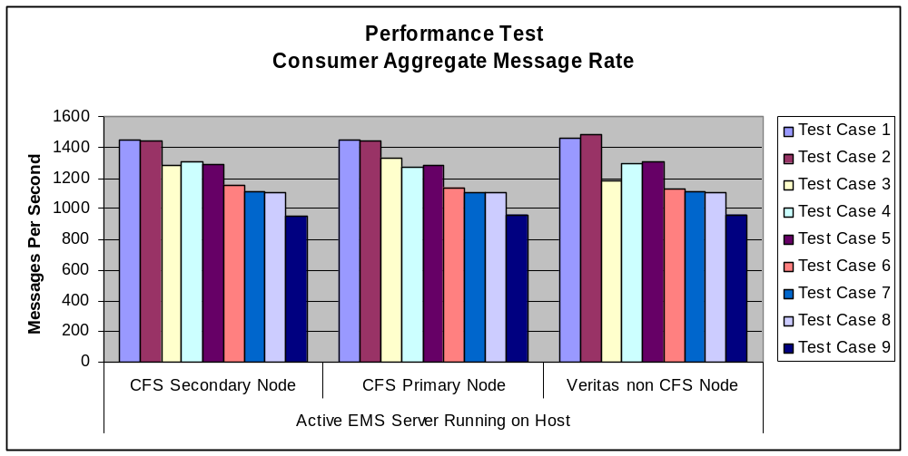
Figure 8 – Performance Test

Resiliency Testing
Objective: To determine the stability of EMS and CFS failover over back and forth every hour for a couple of weeks.
Descriptions: A number of "message loss" clients ran continuously over a two-week period of time while EMS brokers failed over back and forth once per hour. The clients consisted of 100 producers were publishing messages at a rate of 10 messages per second to 100 queues consumed by 100 consumers. Each consumer produced alerts for any error conditions such as duplicate or missing messages. They also noted the outage time between failovers.
The track_message_ids EMS configuration parameter was enabled to eliminate possible duplicate messages from the publishers during failover.
Results:
- No EMS failover problems occurred.
- No messages were lost.
- All client connections reconnected on average less than 1 second.
- 15 Alerts were produced for duplicate message received but the “JMSRedelivered” flag was not set. This is an issue that we raised with Tibco. We suspected a bug in the track_message_ids logic. However, to Tibco’s credit, when we ran the same soak test without the track_message_ids flag enabled, we got many more duplicate messages.
Tibco confirmed that track_message_ids does not prevent 100% message duplication. The bottom line is that consumers must have logic to handle duplicate messages. Refer to Consumer Receives Duplicate Messages of Issues section for further details on this.

Issues

Summary
No issues were found with either CFS or the EMS server. Both functioned as expected in all of the test cases.
The following issues were found with the EMS client. Of these issues, none of them are Tibco problems. The first one is an environmental issue with Solaris 8, the second one is a general TCP timeout issue, and the last one is unavoidable due to race conditions during EMS failover.
- Java Client Reconnect Problem with Multiple Failovers
A problem was discovered with the Java client that has been isolated to an environmental problem in Solaris 8. This condition exists only in Solaris 8 and only when the JVM heap parameters are specified with large values.
Tibco has conducted an investigation of this problem and the result is a Solaris 8 bug.
- Client Reconnect – TCP Socket Timeout
Due to the inherent behavior of TCP, if the EMS server host fails with an OS Panic, then an EMS client has no way of knowing if its socket connection is gone. The underlying TCP socket timeout is very large. Tibco plans to implement a new “client ping” feature in EMS v 4.4 in order to circumvent this problem.
- Duplicate Messages Received by Consumer
A consumer client must be able to handle duplicate messages in an EMS fault tolerant configuration. During a failover, it is impossible for EMS to eliminate the possibility of sending a duplicate message to a consumer.

Veritas CFS
No issues were found. CFS performed exactly as expected in all test cases.

Tibco EMS

EMS Server
No issues were found. EMS Server performed exactly as expected in all test cases.

Java Client Reconnect Problem with Multiple Failovers

Summary
This problem is isolated to Java clients running in Solaris 8 when the JVM large heap parameters are specified.
Tibco has finished investigating this problem and concludes it to be a Solaris 8 bug.

CAUTION
A Sun Solaris 8 bug has been discovered that is isolated to Java clients that specify large heap parameters on the JVM. The manifestation is that after several failovers, the client will hang.

Best Practice
Avoid Solaris 8 for Java clients that need to specify the JVM large heap parameters.

Original Test Results
A minor bug in the Java client API was discovered during the “Message Loss” testing. In this test a java client created 100 consumer and producer connections. It was found that for the first four failovers, all connections reconnected successfully. Then on the fifth failover, some of the connections reconnected but the rest “hung”. At that point, the connections remained in a “hung” state until the EMS server purged the connections when the client reconnect timeout expired.
This problem did not occur with C++ or C# clients. A series of Java client tests were run in order to isolate the problem before reporting it to Tibco.
- The “Connection Failover” tests were repeated failing over back and forth several times. These clients did not perform any message exchange and the problem was not manifested. Every connection successfully reconnected on every failover.
- The “Message Loss” tests were repeated varying the number of producers and consumer sessions the client created. The following chart shows the number of producer and consumer connections created per client, and the number of times EMS failed over before the client application froze.
Client | Producer/Consumer Pairs | EMS Server Failover times successful
1 | 2 | Never failed
2 | 10 | Never failed
3 | 20 | Never failed
4 | 40 | 10 – failed on 11th failover
5 | 60 | 7 – failed on 8th failover
6 | 80 | 6 – failed on 7th failover
7 | 100 | 5 – failed on 5th failover
Table 8 – Java Reconnection Failure Test Results

So to summarize,
- Clients 1-3 never failed. EMS was failed over at least 15 times.
- Clients 4-7 worked fine for a few failovers, all connections reconnected and messages continued to be exchanged. Then at some point, they failed to reconnect. The pattern shows that the greater number of connections took few failover times to freeze up.
- One other observation is that when the clients froze, some of the connections reconnected but not all of them. The ones that didn’t reconnect were totally frozen. Furthermore, on a subsequent failover, even the connections that had successfully reconnected before were now frozen.

Subsequent Analysis with Tibco
After a service ticket was raised to Tibco regarding the test results above, several additional test combinations were run in order to pinpoint the problem.
The two conditions that cause the problem to manifest are
- Java Client running on Solaris 8 AND
- Specifying the “heap allocation” command line parameters on the Java Virtual Machine
“-Xms256m” – this parameter creates a heap with a minimum of 256 MB.
“-Xmx1g” – this parameter causes the heap to grow to a maximum of 1 GB.
In all of the test cases documented in the previous section, the client ran on Solaris 8 using the “heap” command line parameters. Subsequent testing showed there was no problem in Solaris 8 when the JVM heap parameters were not specified.
When the client ran on Solaris 10, there was no problem at all. It didn’t matter whether the client connected to EMS servers on Solaris 10 or Solaris 8 or whether the EMS servers were co-located on the same host or distributed on different hosts.

Tibco Final Summary of Analysis
Tibco performed further testing in order to research the problem
- Updated Solaris 8 with the latest recommended patches
- Activated the ISM (Intimate Shared Memory) feature on Solaris 8. ISM is an option used for large page support.
- Changed EMS tuning parameters (ft_reconnect_timeout increase to 120 seconds)
- Verified TCP parameters were the same between Solaris 8 and Solaris 9.
After making all these changes, the problem still manifested. As a result Tibco concludes the problem is a Solaris 8 bug rather than a configuration tuning issue.

Client Reconnect - TCP Socket Timeout
When an OS panic type failure occurs, clients connected to an EMS server do not get notification that the socket connection is gone. This is an OS TCP behavioral characteristic that EMS has no control of.
We have asked Tibco to implement a higher-level client heartbeat protocol in order to detect an EMS server outage. This would be similar to their existing heartbeat protocol between EMS servers.
Tibco currently has a client_heartbeat EMS configuration parameter; however, its purpose is for the EMS server to detect and disconnect clients that do not maintain a heartbeat with the server. We wish to extend this functionality in the other direction also. We want the client to perform reconnect logic when it doesn’t get heartbeats from the EMS server.
Tibco states that a new “ping” feature will be implemented in EMS version 4.4, due in Q3 of 2006. We do not have detailed documentation yet; however, Tibco states that this feature will solve the issue we are raising here.
We will retest the Reboot and Power Down hardware failure tests with the new EMS version when it is available and advise if this corrects the problem.

Consumer Receives Duplicate Messages
There are a couple of scenarios where a consumer may get a duplicate message. When EMS fails over to another fault tolerant server, there is no way to eliminate the possibility of sending a duplicate message to a consumer. Note duplicate messages can only happen during an EMS failover, even with the highest QOS as follows.
  - Publisher sends persistent messages
  - Destination has “failsafe” property enable. This causes the message to be written synchronously before the send() call completes.
  - EMS server is configured with “track_message_ids” enabled.
  - Consumer connection specifies AutoAck when the session is created.
The bottom line is that in a fault tolerant configuration, the consumer must be able to handle duplicate messages. The following describes a few scenarios where duplicate messages can be sent.

EMS Server Resends Message and sets JMSRedelivered Flag
If the EMS server sends a message to a consumer but does not receive the ACK, then after the failover, the EMS server will resend the message and it will set the JMSRedelivered flag in the Message Header. The following scenarios can happen.
- The consumer never got the original message. In this case, the JMSRedelivered flag is set but the consumer is getting the message for the very first time.
- The consumer got the message and sent the ACK but EMS server never received the ACK. In this case, the JMSRedelivered flag is set and the consumer is getting the message a second time.

Producer API Resends Duplicate Message
When an application sends persistent messages, the API send() call blocks until it receives an ACK from the EMS server. At that time, the API returns to the application. If the EMS connection is broken after the message is sent but before the ACK is received, then after the failover, the API will automatically resend the message to EMS server.

EMS Server Detection of Duplicate Publisher Messages
The “track_message_ids” flag can be set in the EMS configuration file in order to help the EMS server to detect duplicate publisher messages during a failover. When this flag is set, the EMS server checks the Message ID in the message header to see if it has already received this. If it has already received the message, it will throw the message away. In most failover cases, setting this flag causes EMS to correctly detect and throw away most duplicate messages.
However, there is a small case where a duplicate message will not be detected by the EMS server. If the publisher sends a message but doesn’t receive the ACK before the failover, then it will always resend the message. After the failover, EMS is supposed to throw away the duplicate message. However, the following sequence will prevent the EMS server from detecting the duplicate message sent by the publisher.
- Publisher sends message to EMS server but does not receive ACK
- EMS server receives the message and sends it to the consume
- EMS server receives ACK from the consumer
- EMS purges the message from the pending queue
After this sequence the publisher will resend the message and EMS server will not detect it as a duplicate. Note in this case, the consumer will receive the duplicate message and the JMSRedelivered flag will not be set either.

Best Practice
Set the “track_message_ids” parameter in the main EMS configuration file to minimize duplicate messages sent by the publisher during an EMS failover.

Appendix A – Connection Test Results
 | Clients Use Queues Only
 | Queue Clients |  | Failover Reconnect Time (seconds)
Language | Connections | Queues | Shutdown | kill | Kill -9
Java | 100 | 100 | 1 | 2 | 1
Java | 200 | 100 | 4 | 4 | 4
Java | 400 | 100 | 8 | 7 | 8
Java | 800 | 100 | 13 | 17 | 16
Java | 1000 | 100 | 19 | 19 | 20
C# | 1000 | 100 | 16 | 18 | 18
C++ | 1000 | 100 | 4 | 4 | 4

 | Clients Use Topics Only
 | Topic Clients |  | Failover Reconnect Time (seconds)
Language | Connections | Topics | Shutdown | kill |  | kill -9
Java | 100 | 1000 | 2 | 1 |  | 1
Java | 200 | 2000 | 5 | 4 |  | 4
Java | 400 | 4000 | 8 | 9 |  | 9
Java | 800 | 8000 | 17 | 18 |  | 17
Java | 1000 | 10000 | 21 | 20 |  | 21
C# | 1000 | 10000 | 16 | 18 |  | 18
C++ | 1000 | 10000 | 4 | 5 |  | 4

Clients Use Mixture of Topics and Queues
Queue Clients |  | Topic Clients |  | Failover Reconnect Time (seconds)
Connections | Queues | Connections | Topics | Shutdown | kill | kill -9
200 | 100 | 200 | 2000 | 7 | 8 | 8
600 | 100 | 600 | 6000 | 26 | 24 | 26
800 | 100 | 800 | 8000 | 31 | 32 | 32
1000 | 100 | 1000 | 10000 | 41 | 41 | 41

Table 9 – Connection Failover Tests

Appendix B – Hardware Reboot Failure Test Logs
EMS Server Log
2006-06-08 17:34:29 Server is in standby mode for 'tcp://pns51a-0003a.corpny.csfb.com:8888'.
2006-06-08 18:05:32 Missing heartbeats from primary server 'tcp://pns51a-0003a.corpny.csfb.com:8888'.
2006-06-08 18:05:32 Server activating on failure of 'tcp://pns51a-0003a.corpny.csfb.com:8888'.
2006-06-08 18:05:32 Server rereading configuration.
2006-06-08 18:05:50 Recovering state, please wait.
2006-06-08 18:05:50 [emsadmin@0.0.0.0]: Created consumer (connid=108, sessid=107, consid=105) on queue 'Q.1'
2006-06-08 18:05:50 [emsadmin@0.0.0.0]: Created consumer (connid=112, sessid=111, consid=108) on queue 'CFS_QUEUE_0_0'
2006-06-08 18:05:50 [emsadmin@0.0.0.0]: Created producer (connid=110, sessid=109, prodid=106) with empty destination
2006-06-08 18:05:50 Recovered 4 pending connections.

CFS Log
2006/06/08 16:29:05 VCS INFO V-16-1-50135 User root fired command: hares -modify mnt_pn-fi-app-ems_store2 Primary pns51a-0003b from localhost
2006/06/08 18:05:49 VCS INFO V-16-1-10077 Received new cluster membership
2006/06/08 18:05:49 VCS NOTICE V-16-1-10080 System (pns51a-0003b) - Membership: 0x2, Jeopardy: 0x0
2006/06/08 18:05:49 VCS ERROR V-16-1-10079 System pns51a-0003a (Node '0') is in Down State - Membership: 0x2
2006/06/08 18:05:49 VCS ERROR V-16-1-10322 System pns51a-0003a (Node '0') changed state from RUNNING to FAULTED
2006/06/08 18:05:49 VCS NOTICE V-16-1-10446 Group cvm is offline on system pns51a-0003a
2006/06/08 18:05:49 VCS NOTICE V-16-1-10446 Group pn-fi-app-athena03_sg is offline on system pns51a-0003a
2006/06/08 18:05:49 VCS NOTICE V-16-1-10446 Group sg_devfiathenacfs01 is offline on system pns51a-0003a
2006/06/08 18:05:49 VCS INFO V-16-1-10493 Evaluating pns51a-0003a as potential target node for group pn-fi-app-athena03_sg
2006/06/08 18:05:49 VCS INFO V-16-1-10494 System pns51a-0003a not in RUNNING state
2006/06/08 18:05:49 VCS INFO V-16-1-10493 Evaluating pns51a-0003b as potential target node for group pn-fi-app-athena03_sg
2006/06/08 18:05:49 VCS NOTICE V-16-1-10301 Initiating Online of Resource ip_pn-fi-app-athena03 (Owner: unknown, Group: pn-fi-app-athena03_sg) on System pns51a-0003b
2006/06/08 18:05:49 VCS INFO V-16-6-15004 (pns51a-0003b) hatrigger:Failed to send trigger for sysoffline; script doesn't exist
2006/06/08 18:05:49 VCS INFO V-16-1-10298 Resource ip_pn-fi-app-athena03 (Owner: unknown, Group: pn-fi-app-athena03_sg) is online on pns51a-0003b (VCS initiated)
2006/06/08 18:05:49 VCS NOTICE V-16-1-10447 Group pn-fi-app-athena03_sg is online on system pns51a-0003b
2006/06/08 18:05:49 VCS NOTICE V-16-1-10448 Group pn-fi-app-athena03_sg failed over to system pns51a-0003b
2006/06/08 18:05:50 VCS INFO V-16-6-15002 (pns51a-0003b) hatrigger:hatrigger executed /opt/VRTSvcs/bin/triggers/nfs_restart pn-fi-app-athena03_sg successfully
2006/06/08 18:05:50 VCS INFO V-16-6-15004 (pns51a-0003b) hatrigger:Failed to send trigger for postonline; script doesn't exist
2006/06/08 18:06:04 VCS INFO V-16-1-50135 User root fired command: hares -modify mnt_pn-fi-app-ems_store1 Primary pns51a-0003b from localhost

Appendix C – Hardware Power Down Failure Test Logs
Java Client Pub and Sub Log
sub dest=Queue[Q.1]
pubcnt=99000000
msgcnt=99000000
CONNECTION EXCEPTION: Publisher ThreadId=1, FT-SWITCH: tcp://pns51a-0003b.fir.fbc.com:8889, Connection has performed fault-tolerant switch to tcp://pns51a-0003b.fir.fbc.com:8889
Wed Jul 05 17:52:28 EDT 2006: PUBLISHER FAILOVER EVENT - first publisher reconnected
Wed Jul 05 17:52:28 EDT 2006: PUBLISHER FAILOVER EVENT - last publisher reconnected
CONNECTION EXCEPTION: Subscriber ThreadId=1, FT-SWITCH: tcp://pns51a-0003b.fir.fbc.com:8889, Connection has performed fault-tolerant switch to tcp://pns51a-0003b.fir.fbc.com:8889
Wed Jul 05 17:54:01 EDT 2006: SUBSCRIBER FAILOVER EVENT - first subscriber reconnected
Wed Jul 05 17:54:01 EDT 2006: SUBSCRIBER FAILOVER EVENT - last subscriber reconnected
FAILOVER TIME: Sub1=617246, min time=617246, max time=617246
Wed Jul 05 17:54:01 EDT 2006: FAILOVER SUMMARY: 1 consumers reconnected, min time=617246, max time=617246

EMS Server Log
2006-07-05 17:21:06 Server is in standby mode for 'tcp://pns51a-0003a.corpny.csfb.com:8888'.
2006-07-05 17:43:48 Missing heartbeats from primary server 'tcp://pns51a-0003a.corpny.csfb.com:8888'.
2006-07-05 17:43:48 Server activating on failure of 'tcp://pns51a-0003a.corpny.csfb.com:8888'.
2006-07-05 17:43:48 Server rereading configuration.
2006-07-05 17:44:06 Recovering state, please wait.
2006-07-05 17:44:06 [emsadmin@0.0.0.0]: Created consumer (connid=108, sessid=107, consid=105) on queue 'Q.1'
2006-07-05 17:44:06 [emsadmin@0.0.0.0]: Created consumer (connid=112, sessid=111, consid=108) on queue 'CFS_QUEUE_0_0'
2006-07-05 17:44:06 [emsadmin@0.0.0.0]: Created producer (connid=110, sessid=109, prodid=106) with empty destination
2006-07-05 17:44:06 [emsadmin@0.0.0.0]: Created producer (connid=114, sessid=113, prodid=109) into queue 'CFS_QUEUE_0_0'
2006-07-05 17:44:07 Recovered 5 pending connections.
2006-07-05 17:44:07 Server is now active.
2006-07-05 17:51:55 [emsadmin@nys45a-6902]: Reconnected, connection id=112, type: generic
2006-07-05 17:52:28 [emsadmin@nys45a-6902]: Reconnected, connection id=110, type: generic
2006-07-05 17:52:42 WARNING: Backup server '<unknown>' disconnected.
2006-07-05 17:53:30 [a@pns51a-0003b]: Connected, connection id=117, type: admin
2006-07-05 17:53:30 [a@pns51a-0003b]: Created consumer (connid=117, sessid=114, consid=109) on queue '$TMP$.bench.22CA44AC2D4272.1'
2006-07-05 17:53:30 [a@pns51a-0003b]: Created producer (connid=117, sessid=114, prodid=110) into queue '$sys.admin'
2006-07-05 17:54:01 [emsadmin@nys45a-6902]: Reconnected, connection id=108, type: generic
2006-07-05 17:56:18 [emsadmin@nys45a-6902]: Destroyed consumer (connid=112, sessid=111, consid=108) on queue 'CFS_QUEUE_0_0'
2006-07-05 17:56:18 [emsadmin@nys45a-6902]: Disconnected, id=112, reason: connection closed (iothr.c:207)
2006-07-05 18:04:07 [emsadmin@0.0.0.0]: connection id=114 purged after FT timeout
2006-07-05 18:04:07 [emsadmin@0.0.0.0]: Destroyed producer (connid=114, sessid=113, prodid=109) into queue 'CFS_QUEUE_0_0'
2006-07-05 18:04:19 Purged 1 connection.

CFS Log
2006/07/05 17:44:05 VCS INFO V-16-1-10077 Received new cluster membership
2006/07/05 17:44:05 VCS NOTICE V-16-1-10080 System (pns51a-0003b) - Membership: 0x2, Jeopardy: 0x0
2006/07/05 17:44:05 VCS ERROR V-16-1-10079 System pns51a-0003a (Node '0') is in Down State - Membership: 0x2
2006/07/05 17:44:05 VCS ERROR V-16-1-10322 System pns51a-0003a (Node '0') changed state from RUNNING to FAULTED
2006/07/05 17:44:05 VCS NOTICE V-16-1-10446 Group cvm is offline on system pns51a-0003a
2006/07/05 17:44:05 VCS NOTICE V-16-1-10446 Group pn-fi-sas-dev01_sg is offline on system pns51a-0003a
2006/07/05 17:44:05 VCS NOTICE V-16-1-10446 Group sg_devfiathenacfs01 is offline on system pns51a-0003a
2006/07/05 17:44:05 VCS INFO V-16-1-10493 Evaluating pns51a-0003a as potential target node for group pn-fi-sas-dev01_sg
2006/07/05 17:44:05 VCS INFO V-16-1-10494 System pns51a-0003a not in RUNNING state
2006/07/05 17:44:05 VCS INFO V-16-1-10493 Evaluating pns51a-0003b as potential target node for group pn-fi-sas-dev01_sg
2006/07/05 17:44:05 VCS NOTICE V-16-1-10301 Initiating Online of Resource ip_pn-fi-sas-dev01 (Owner: unknown, Group: pn-fi-sas-dev01_sg) on System pns51a-0003b
2006/07/05 17:44:05 VCS NOTICE V-16-1-10301 Initiating Online of Resource vxdg_pn-fi-sas-dev01_dg (Owner: unknown, Group: pn-fi-sas-dev01_sg) on System pns51a-0003b
2006/07/05 17:44:05 VCS INFO V-16-6-15004 (pns51a-0003b) hatrigger:Failed to send trigger for sysoffline; script doesn't exist
2006/07/05 17:44:05 VCS WARNING V-16-10001-1014 (pns51a-0003b) DiskGroup:vxdg_pn-fi-sas-dev01_dg:online:Diskgroups will be imported without reservations
2006/07/05 17:44:05 VCS INFO V-16-1-10298 Resource ip_pn-fi-sas-dev01 (Owner: unknown, Group: pn-fi-sas-dev01_sg) is online on pns51a-0003b (VCS initiated)
2006/07/05 17:44:10 VCS WARNING V-16-10001-1001 (pns51a-0003b) DiskGroup:vxdg_pn-fi-sas-dev01_dg:online:vxdg import failed. Trying again with clear flag option
2006/07/05 17:44:11 VCS NOTICE V-16-10001-1007 (pns51a-0003b) DiskGroup:vxdg_pn-fi-sas-dev01_dg:online:vxdg import (clear flag) succeeded on DiskGroup pn-fi-sas-dev01_dg
2006/07/05 17:44:11 VCS NOTICE V-16-10001-1010 (pns51a-0003b) DiskGroup:vxdg_pn-fi-sas-dev01_dg:online:Volumes in Disk Group pn-fi-sas-dev01_dg are started. Any mirrors
are updated in background
2006/07/05 17:44:13 VCS INFO V-16-1-10298 Resource vxdg_pn-fi-sas-dev01_dg (Owner: unknown, Group: pn-fi-sas-dev01_sg) is online on pns51a-0003b (VCS initiated)
2006/07/05 17:44:13 VCS NOTICE V-16-1-10301 Initiating Online of Resource mnt_pn-fi-sas-dev01 (Owner: unknown, Group: pn-fi-sas-dev01_sg) on System pns51a-0003b
2006/07/05 17:44:13 VCS INFO V-16-10001-5505 (pns51a-0003b) Mount:mnt_pn-fi-sas-dev01:online:Executing vxfs log replay
2006/07/05 17:44:15 VCS INFO V-16-2-13001 (pns51a-0003b) Resource(mnt_pn-fi-sas-dev01): Output of the completed operation (online)
UX:vxfs mount: ERROR: V-3-21268: /dev/vx/dsk/pn-fi-sas-dev01_dg/pn-fi-sas-dev01 is corrupted. needs checking
/app/pn-fi-sas-dev01:
UX:vxfs mount: ERROR: V-3-21268: /dev/vx/dsk/pn-fi-sas-dev01_dg/pn-fi-sas-dev01 is corrupted. needs checking
log replay in progress
replay complete - marking super-block as CLEAN
2006/07/05 17:44:16 VCS INFO V-16-1-10298 Resource mnt_pn-fi-sas-dev01 (Owner: unknown, Group: pn-fi-sas-dev01_sg) is online on pns51a-0003b (VCS initiated)
2006/07/05 17:44:16 VCS NOTICE V-16-1-10447 Group pn-fi-sas-dev01_sg is online on system pns51a-0003b
2006/07/05 17:44:16 VCS NOTICE V-16-1-10448 Group pn-fi-sas-dev01_sg failed over to system pns51a-0003b
2006/07/05 17:44:16 VCS INFO V-16-6-15002 (pns51a-0003b) hatrigger:hatrigger executed /opt/VRTSvcs/bin/triggers/nfs_restart pn-fi-sas-dev01_sg successfully
2006/07/05 17:44:16 VCS INFO V-16-6-15004 (pns51a-0003b) hatrigger:Failed to send trigger for postonline; script doesn't exist
2006/07/05 17:44:46 VCS INFO V-16-1-50135 User root fired command: hares -modify mnt_pn-fi-app-ems_store1 Primary pns51a-0003b from localhost

Netstat Log
Note these samples were taken in a polling loop every second. Hence these times are on average 1 second later than what the client reports. The client reports the event dynamically when it happens.
Wed Jul 5 17:43:00 EDT 2006 - Node A powered down (manual clock verification)

nys45a-6902.35737 pns51a-0003a.8888 66608 0 131768 0 ESTABLISHED
nys45a-6902.35741 pns51a-0003a.8888 66608 0 131768 0 ESTABLISHED
Wed Jul 5 17:43:00 EDT 2006
nys45a-6902.35749 pns51a-0003a.8888 66608 0 68056 0 ESTABLISHED

Wed Jul 5 17:51:54 EDT 2006
nys45a-6902.35737 pns51a-0003a.8888 66608 55 131768 0 ESTABLISHED
nys45a-6902.35741 pns51a-0003a.8888 66608 579 131768 0 ESTABLISHED
nys45a-6902.35749 pns51a-0003a.8888 66608 391 68056 0 ESTABLISHED

Wed Jul 5 17:51:55 EDT 2006
nys45a-6902.35737 pns51a-0003a.8888 66608 55 131768 0 ESTABLISHED
nys45a-6902.35741 pns51a-0003a.8888 66608 579 131768 0 ESTABLISHED
nys45a-6902.36279 pns51a-0003b.8889 66608 0 68056 0 ESTABLISHED

Wed Jul 5 17:52:29 EDT 2006 - Java Publisher reconnects 9.5 minutes after Power Down
nys45a-6902.35737 pns51a-0003a.8888 66608 63 131768 0 ESTABLISHED
nys45a-6902.36279 pns51a-0003b.8889 66608 0 68056 0 ESTABLISHED
nys45a-6902.36308 pns51a-0003b.8889 66608 0 131768 0 ESTABLISHED

Wed Jul 5 17:53:00 EDT 2006 - Node A powered up (manual clock verification)

Wed Jul 5 17:54:02 EDT 2006 - Java Subscriber reconnects - 1 minute after Node A Power Up
nys45a-6902.36279 pns51a-0003b.8889 66608 0 68056 0 ESTABLISHED
nys45a-6902.36308 pns51a-0003b.8889 66608 0 131768 0 ESTABLISHED
nys45a-6902.36382 pns51a-0003b.8889 66608 0 131768 0 ESTABLISHED

Appendix D - Pending Message Recovery Test Results
Objective: To determine the length of time EMS takes to recover pending messages during failover.

Description: A series of tests were run to create pending messages in the EMS server. The numbers of publishers, subscribers, and messages were varied in each test case. After pending messages had accumulated, the primary EMS server was terminated and the time to recover those messages was noted. There were two EMS failovers in this test sequence.

Failover 1: Publish messages such that they are not consumed, then cause EMS failover, then start consumers. This sequence produces the following statistics:
- Ta: The amount of time for the secondary server to recover all of the pending messages.
- Tb: After the pending messages are recovered, the amount of time for the subscribers to consume 50% of those messages.

Failover 2: Exactly the same test except failover is from secondary server back to primary.
- Tc: The amount of time for the primary server to recover all of the pending messages.
- Td: After the pending messages are recovered, the amount of time for the subscribers to consume 50% of those messages.

For each of the test cases perform the following operations A, B, C, D. Single broker test case will run on 'hostname'. Terminate is "kill -9".
Batch Size for all test cases would be 50. Every publisher and subscriber pair has its own topic
A | 1 | Durable subscribers register subscriptions and exit without de-registering
 | 2 | Start publishers
 | 3 | Terminate the broker when pub-count messages per publisher have been published
 | 4 | Start the broker and note recovery time Ta
B | 1 | Bring up the subscribers
 | 2 | The subscribers exits, when sub-count (i.e. 50% of pub-count) messages per subscriber have been consumed
 | 3 | Note sub-count consumption time Tb for each subscriber
C | 1 | Bring up the publishers and the subscribers
 | 2 | While the publishers publish and the subscribers have consumed the next 50% of the messages from A pause the subscribers
 | 3 | Terminate the broker when pub-count messages per publisher have been published
 | 4 | Start the broker and note recovery time Tc
D | 1 | Bring up the subscribers
 | 2 | Note sub-count (i.e 50% of pub-count) consumption time Td for each subscriber

Results:

This table shows that pending message recovery is a linear function of how many messages there are to recover. Note the recovery times were measured with a granularity in seconds. Note the first value of Ta=0 simply means that it took less than 1 second.

Constants | recovery log size=Size-1; mess size=2KB; Persistent; Durable; Transactional; Batch(1)
1.1 | No. of Pub | No. of Sub | No. of Topics | pub-count / publisher | sub-count / subscriber | Msg size (MBytes) recovered for A, C | Time (secs)
 |  |  |  |  |  |  | Ta | Tb | Tc | Td
1.1.1 | 1 | 1 | 1 | 1,000 | 500 | 2,000,000 | 0 | 0.340 | 1 | 0.256
 | 1 | 1 | 1 | 3,000 | 1,500 | 6,000,000 | 2 | 0.709 | 1 | 0.704
 | 1 | 1 | 1 | 10,000 | 5,000 | 20,000,000 | 2 | 2.012 | 1 | 2.081
 | 1 | 1 | 1 | 12,000 | 6,000 | 24,000,000 | 2 | 2.378 | 2 | 2.414
1.1.2 | 25 | 25 | 25 | 1,000 | 500 | 50,000,000 | 2 | 1.537 | 2 | 1.273
 | 25 | 25 | 25 | 3,000 | 1,500 | 150,000,000 | 6 | 5.756 | 5 | 5.966
 | 25 | 25 | 25 | 10,000 | 5,000 | 500,000,000 | 16 | 22.464 | 17 | 23.072
 | 25 | 25 | 25 | 12,000 | 6,000 | 600,000,000 | 20 | 26.840 | 21 | 28.293
1.1.3 | 50 | 50 | 50 | 1,000 | 500 | 100,000,000 | 3 | 1.741 | 4 | 1.572
 | 50 | 50 | 50 | 3,000 | 1,500 | 300,000,000 | 10 | 10.578 | 11 | 10.875
 | 50 | 50 | 50 | 10,000 | 5,000 | 1,000,000,000 | 32 | 46.594 | 32 | 47.293
 | 50 | 50 | 50 | 12,000 | 6,000 | 1,200,000,000 | 38 | 57.381 | 39 | 57.516
1.1.4 | 75 | 75 | 75 | 1,000 | 500 | 150,000,000 | 6 | 1.801 | 5 | 2.232
 | 75 | 75 | 75 | 3,000 | 1,500 | 450,000,000 | 15 | 15.891 | 16 | 16.850
 | 75 | 75 | 75 | 10,000 | 5,000 | 1,500,000,000 | 47 | 73.290 | 49 | 75.550
 | 75 | 75 | 75 | 12,000 | 6,000 | 1,800,000,000 | 65 | 92.483 | 65 | 94.612
1.1.5 | 100 | 100 | 100 | 1,000 | 500 | 200,000,000 | 7 | 1.842 | 8 | 2.127
 | 100 | 100 | 100 | 3,000 | 1,500 | 600,000,000 | 20 | 20.808 | 20 | 21.310
 | 100 | 100 | 100 | 10,000 | 5,000 | 2,000,000,000 | 72 | 103.399 | 71 | 105.580
 | 100 | 100 | 100 | 12,000 | 6,000 | 2,400,000,000 | 89 | 128.213 | 87 | 130.667

Table 10 – EMS Recovery Test Results

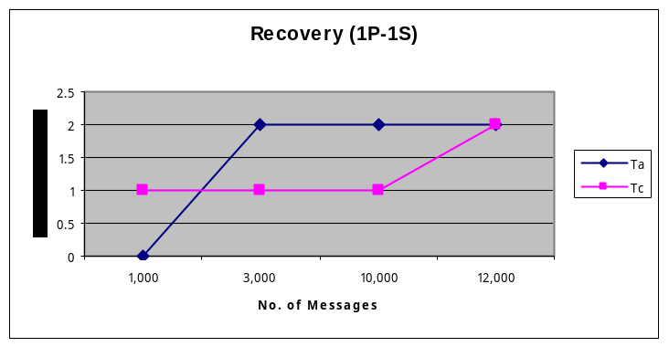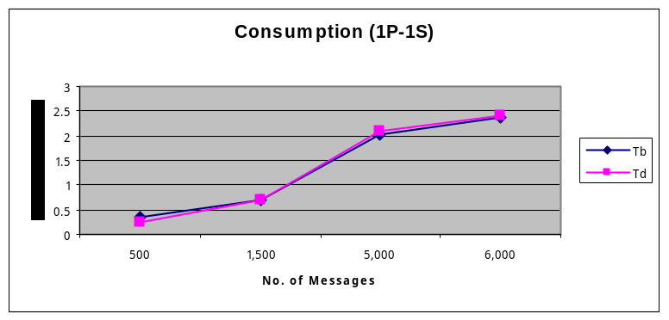
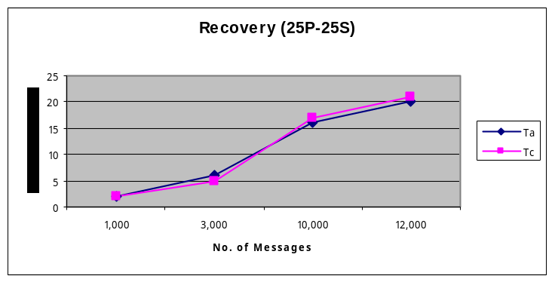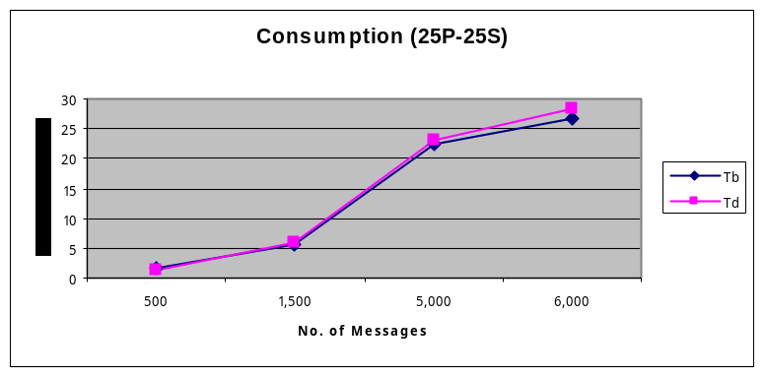
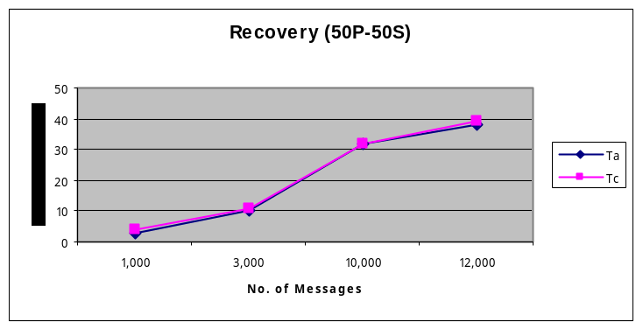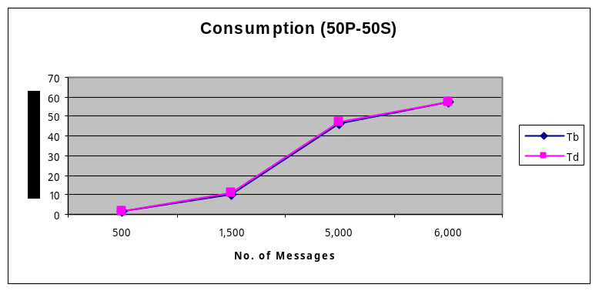
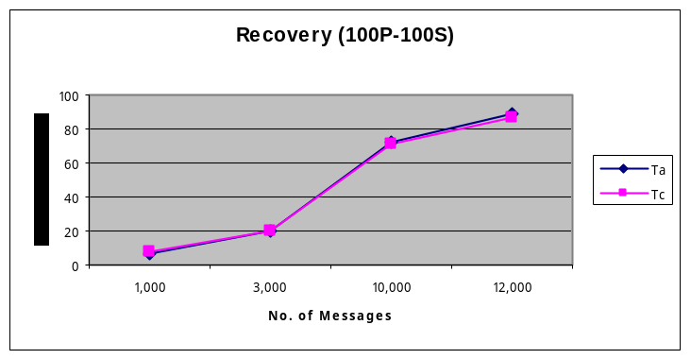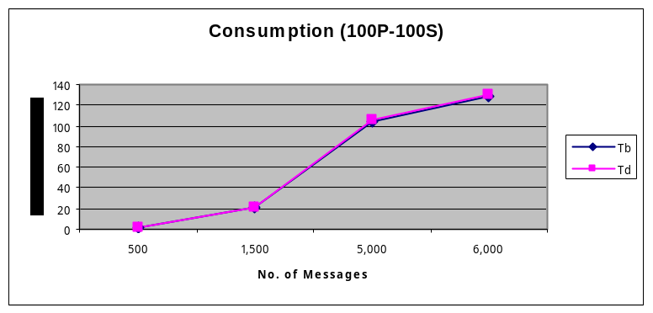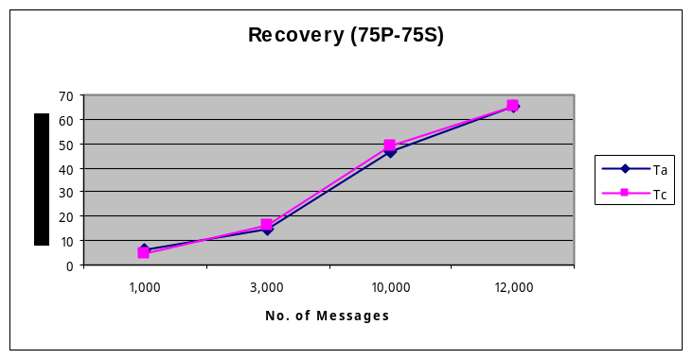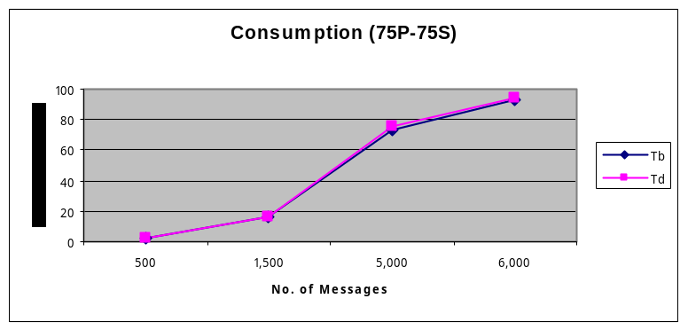
Figure 9 – EMS Recovery Test Graphs

Appendix E – Performance Test Results
Client Connected to EMS running on the CFS Primary Lock Manager Node
Test Case | Msg Size | Prefetch | Producer msg/sec | Producer-Consumer |  |  |  | Consumer (msgs/sec) |  |  | Latency (ms)
 |  |  |  | Aggregate msg/sec | TranTime Avg(ms) | TranTime Min(ms) | TranTime Max(ms) | Aggregate | Min | Max | Avg | Min | Max
1 | 1K | none | 371 | 362 | 2 | 1 | 56 | 1451 | 362 | 362 | 701 | 10 | 836
2 | 1K | 5 | 367 | 360 | 2 | 1 | 134 | 1440 | 360 | 360 | 585 | 11 | 737
3 | 1K | 20 | 415 | 332 | 3 | 2 | 56 | 1328 | 332 | 332 | 4158 | 9 | 7298
4 | 2K | none | 336 | 317 | 3 | 2 | 129 | 1269 | 317 | 317 | 1509 | 10 | 2147
5 | 2K | 5 | 331 | 322 | 3 | 2 | 132 | 1288 | 322 | 322 | 877 | 11 | 1205
6 | 2K | 20 | 374 | 285 | 3 | 2 | 109 | 1141 | 285 | 285 | 5534 | 11 | 10050
7 | 4K | none | 298 | 276 | 3 | 2 | 103 | 1107 | 276 | 276 | 2064 | 13 | 3271
8 | 4K | 5 | 305 | 275 | 3 | 2 | 164 | 1100 | 275 | 275 | 2767 | 12 | 4441
9 | 4K | 20 | 331 | 239 | 4 | 2 | 376 | 959 | 239 | 239 | 7498 | 11 | 13900

Client Connected to EMS running on the CFS Secondary Lock Manager Node
Test Case | Msg Size | Prefetch | Producer msg/sec | Producer-Consumer |  |  |  | Consumer (msgs/sec) |  |  | Latency (ms)
 |  |  |  | Aggregate msg/sec | TranTime Avg(ms) | TranTime Min(ms) | TranTime Max(ms) | Aggregate | Min | Max | Avg | Min | Max
1 | 1K | none | 375 | 362 | 2 | 1 | 79 | 1449 | 362 | 362 | 891 | 10 | 1211
2 | 1K | 5 | 371 | 361 | 2 | 1 | 185 | 1444 | 361 | 361 | 743 | 8 | 1098
3 | 1K | 20 | 403 | 320 | 3 | 1 | 785 | 1282 | 320 | 320 | 4560 | 9 | 7703
4 | 2K | none | 348 | 326 | 3 | 1 | 84 | 1305 | 326 | 326 | 1585 | 10 | 2372
5 | 2K | 5 | 338 | 320 | 3 | 2 | 702 | 1282 | 320 | 320 | 1483 | 10 | 2406
6 | 2K | 20 | 374 | 287 | 3 | 2 | 142 | 1152 | 288 | 288 | 5322 | 9 | 9616
7 | 4K | none | 301 | 277 | 3 | 2 | 199 | 1111 | 277 | 277 | 2276 | 14 | 3484
8 | 4K | 5 | 298 | 275 | 3 | 2 | 195 | 1101 | 275 | 275 | 2391 | 14 | 3441
9 | 4K | 20 | 328 | 237 | 4 | 2 | 258 | 949 | 237 | 237 | 7510 | 10 | 14148

Table 11 – EMS Performance in CFS Environment
Client Connected to EMS running in non CFS environment
Test Case | Msg Size | Prefetch | Producer msg/sec | Producer-Consumer |  |  |  | Consumer (msgs/sec) |  |  | Latency (ms)
 |  |  |  | Aggregatemsgs/sec | TranTime Avg(ms) | TranTime Min(ms) | TranTime Max(ms) | Aggregate | Min | Max | Avg | Min | Max
1 | 1K | none | 385 | 365 | 2 | 1 | 55 | 1461 | 365 | 365 | 1160 | 9 | 1887
2 | 1K | 5 | 382 | 370 | 2 | 1 | 58 | 1482 | 370 | 370 | 786 | 8 | 1123
3 | 1K | 20 | 362 | 293 | 3 | 2 | 128 | 1175 | 293 | 293 | 4764 | 11 | 7776
4 | 2K | none | 347 | 325 | 3 | 1 | 67 | 1301 | 325 | 325 | 1571 | 12 | 2447
5 | 2K | 5 | 339 | 326 | 3 | 2 | 191 | 1307 | 326 | 326 | 1153 | 10 | 1551
6 | 2K | 20 | 368 | 281 | 3 | 2 | 193 | 1125 | 281 | 281 | 5794 | 10 | 10307
7 | 4K | none | 310 | 277 | 3 | 2 | 164 | 1111 | 277 | 277 | 2757 | 12 | 4696
8 | 4K | 5 | 302 | 275 | 3 | 2 | 162 | 1103 | 275 | 275 | 2383 | 15 | 3960
9 | 4K | 20 | 332 | 239 | 4 | 2 | 212 | 957 | 239 | 239 | 7601 | 14 | 13993

Table 12 – EMS Performance in Veritas Regular File System Environment

It is important to pre-allocate the EMS Datastore in order to get the best performance. For this certification, the data store was pre-allocated to 1 GByte.
Disable “Interrupt Coalescing. Refer to Best Practice comment.
I/O fencing is used to protect data when both primary and secondary nodes write to the disk at the same time. Refer to Best Practices above for further information.
The Cluster Volume Manager Timeout parameter controls which node will become primary during a CFS Fault when there are more than two nodes in the cluster. This parameter is irrelevant for EMS because there are only two nodes in the cluster. In a two node cluster, the secondary does not have to negotiate with other nodes when the primary goes down.
The Global Atomic Broadcast Timeout parameter is the “heartbeat” timeout and determines when the secondary node realizes the primary node is no longer active. Veritas recommends a 15 second timeout because network “glitches” can produce unwanted side effects when the value is too low. A timeout causes a lot of data to be transmitted through the CFS heartbeat channels.

